BrandPush releases a new template to help clients create quality press releases

BrandPush has crafted an easy-to-use template for their clients to use when writing news articles. They hope that this will make the ordering process on their website easier for their clients.

The team over at BrandPush have crafted a new writing template for their clients to use when preparing press releases.

"I really hope that this article can help provide the basic structure, look, and feel of how a press release should be," said Julia, one of BrandPush's expert writers, "I created the template to show off all the different formatting options that our clients can use when writing their own press release."

The BrandPush team work with hundreds of news sites, all of which have unique requirements for news articles. However, the BrandPush team has put together a list of easy-to-follow guidelines for writers to meet the needs of all news sites:

- Articles must be in Press Release format.
- Articles must be between 350-800 words.
- The headline must summarize the article in a single line and should include your brand name.
- Writers must use a professional tone without exaggeration or hype.
- Articles must be neutral and informational, not a salesperson.
- Articles must be written as a third party without personal pronouns like "we" or "you."
- Articles may include 1 link for every 200 words.
- Articles may include 1 image for every 250 words.
- Articles must be written in English.

"There's a lot of room for creativity within a press release," Julia continues, "the writer can include things like images, links, quotes, bullet points, and use bolded text for headings. This really gives the writer a lot of flexibility".

Most common mistakes within Press Releases

When asked what the most common mistakes she sees in press releases, Julia says, "well, usually there are two things I see almost daily. The first is that the article is not a press release at all. Many people write blog posts or sales pitches that our news networks simply will not approve. The second is either using too many images or too many links. Anyone who has experience in search engine optimization knows that too many links can hurt your ranking on Google. Here at BrandPush, we suggest 2-3 images and a maximum of 5 links".

Including YouTube Videos

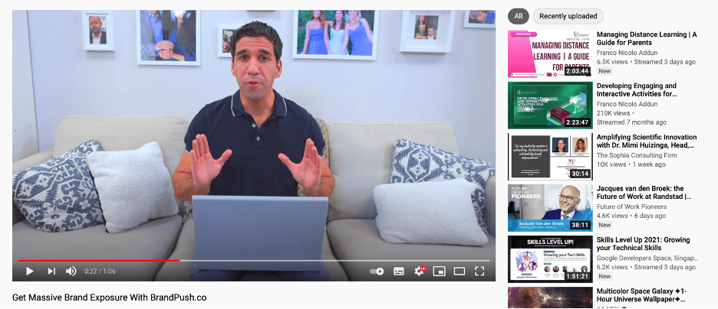

Articles that BrandPush publishes also have the ability to include an embedded YouTube video. But the team asks that you include a link to the YouTube video inside the "additional notes" section of their order form since Microsoft Word and PDF documents do not allow video embeds.

The easy solution to writing

The writing team over at BrandPush has successfully published hundreds of Press Releases that meet their news networks' requirements and their clients' goals. They offer this writing service on their Plus and Pro Plans as an all-in-one package for clients who want to save time writing and hand that task over to professionals.

Conclusion
For anyone who wants to write their own press release, BrandPush offers a great template to help write it. Along with the writing guidelines linked on their homepage, writing a newsworthy article has never been easier.

